**ABOUT THE PROJECT:**

* CodeX is a German beverage company seeking to establish itself in the Indian market.
* Several months ago, they introduced their energy drink in 10 cities across India. The Marketing team is tasked with boosting brand awareness, expanding market share, and advancing product development.
* They conducted a survey in these 10 cities and collected responses from 10,000 participants.
* As a data analyst, my role is to convert these survey findings into actionable insights that can guide the team's decisions.

**TOOLS USED:**

* Microsoft Excel
* Microsoft Word
* Microsoft PowerPoint

**CATEGORIES / CLASSIFICATIONS:**

* DEMOGRAPHIC INSIGHTS
* CONSUMER PREFERENCES
* COMPETITION ANALYSIS
* MARKETING CHANNELS
* BRAND AWARENESS
* BRAND PENETRATION
* PURCHASE BEHAVIOR
* PRODUCT DEVELOPMENT
* RECOMMENDATION FOR CODEX

**Provide Insights to the Marketing Team in Food & Beverage Industry**

**DEMOGRAPHIC INSIGHTS**

1. **Who prefers energy drink more? (male/female/non-binary?)**

**ANSWER: -**

Males exhibit a stronger preference for energy drinks compared to females and non-binary individuals.

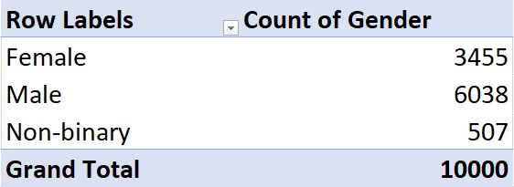

1. **Which age group prefers energy drinks more?**

**ANSWER: -**

The age bracket of 19-30 exhibits the strongest preference for energy drinks.

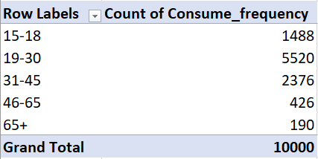

.

1. **Which type of marketing reaches the most Youth (15-30)?**

**ANSWER: -**

Online advertisements are most effective in reaching the youth (15-30 age group), with 2666 respondents exposed to them, followed by TV commercials with 1290 respondents.

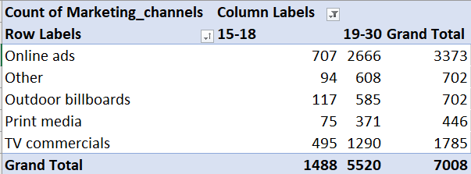

**CONSUMER PREFERENCES:**

1. **What are the preferred ingredients of energy drinks among respondents?**

**ANSWER: -**

Based on the data, respondents prefer energy drinks with caffeine, vitamins, sugar, and guarana, with caffeine as the most favored ingredient.

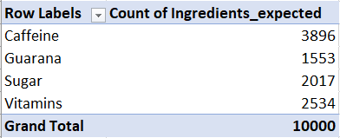

1. **What packaging preferences do respondents have for energy drinks?**

**ANSWER: -**

Based on data respondents prefer energy drink packaging in compact and portable cans, totaling 3984

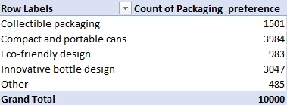

.

**COMPETITION ANALYSIS:**

1. **Who are the current market leaders?**

**ANSWER: -**

Cola-Coka holds the top position in the Indian market.

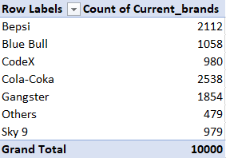

1. **What are the primary reasons consumers prefer those brands over ours?**

**ANSWER: -**

The primary reasons consumers prefer other brands over CodeX are:

Brand reputation & Taste/flavor preference

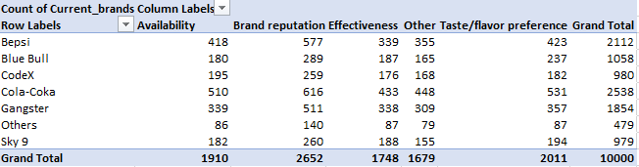

**MARKETING CHANNELS AND BRAND AWARENESS:**

1. **Which marketing channel can be used to reach more customers?**

**ANSWER: -**

The marketing channels that reach the highest number of customers are online ads and TV commercials, with 4020 and 2688 respondents exposed to them, respectively.

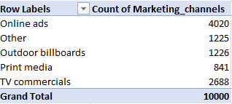

**b. How effective are different marketing strategies and channels in reaching our customers?**

**ANSWER: -**

Online advertisements and TV commercials demonstrate notable effectiveness, reaching 4020 and 2688 respondents, respectively. Outdoor billboards, other channels, and print media show lower but still significant engagement, connecting with 1226, 1225, and 841 respondents, respectively.

**BRAND PENETRATION:**

**a. What do people think about our brand? (Overall rating)**

**ANSWER: -**

CodeX exhibits a competitive 3.3 rating, aligning with industry standards. Improving taste profiles and expanding product availability channels are essential to boost consumer satisfaction and stay relevant in the market.

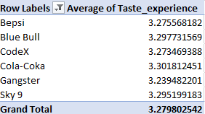

**OVERALL RATING OF ALL BRAMD:**

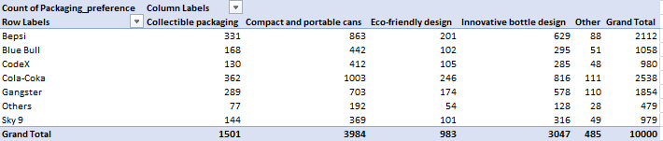

1. **Which cities do we need to focus more on?**

**ANSWER: -**

Cities like Bangalore, Hyderabad, and Mumbai show a higher proportion of neutral perceptions, highlighting areas where targeted efforts are necessary to shift consumer sentiment towards positivity and improve brand perception.

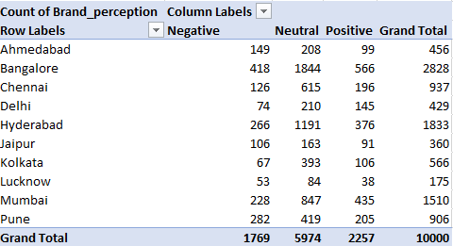

**PURCHASE BEHAVIOR:**

1. **Where do respondents prefer to purchase energy drinks?**

**ANSWER: -**

Respondents prefer purchasing energy drinks from supermarkets, with 4494 indicating

this as their preferred purchase location.

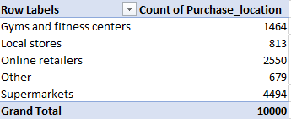

1. **What are the typical consumption situations for energy drinks among respondents?**

**ANSWER: -**

Individuals consume energy drinks during work, study, or exercise, frequently before physical activity to enhance their energy levels.

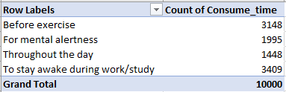

1. **What factors influence respondents' purchase decisions, such as price range and limited edition packaging?**

**ANSWER: -**

1. Price range significantly influences purchase decisions, with a majority falling within the 50 - 99 and 100 - 150 ranges.

**PRICE RANGE:**

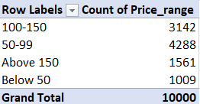

**LIMITED EDITION PACKAGING:**

**ANSWER: -**

2- Limited edition packaging is also influential, with a notable preference among respondents.

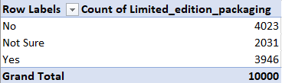

**PRODUCT DEVELOPMENT:**

1. **Which area of business should we focus more on our product development? (Branding/taste/availability)**

**ANSWER: -**

Based on the data, prioritizing the enhancement of brand reputation and availability could be essential for product development, as these factors have the highest count among those influencing consumer preferences for CodeX.



**SECONDARY INSIGHTS**

**ANSWER: -**



**PRICE RANGE DISTRIBUTION FOR CODEX PRODUCT**

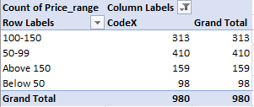

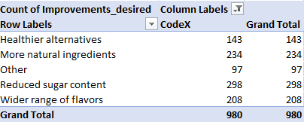

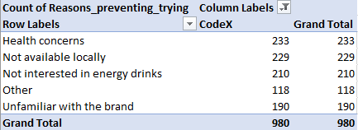

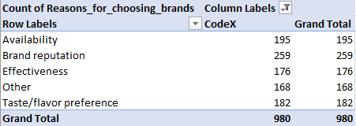

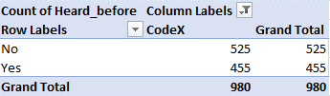

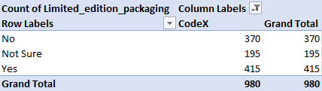

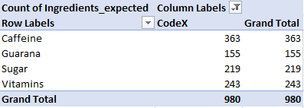

**IMPROVEMENTS FOR CODEX PRODUCT:**

**1. Price Range Alignment:**

* Based on the analysis, a substantial number of CodeX users are in the price range of $50–$99
* It's advisable to consider adapting pricing strategies to better meet the preferences and affordability of this segment.

**2. Desired Product Enhancements:**

Respondents express a desire for:

* Reduced sugar content
* More natural ingredients

Implementing these enhancements could help address health considerations and align with consumer preferences for healthier choices.

**3. Reasons for Brand Loyalty:**

CodeX brand loyalty is driven by:

* Brand reputation
* Availability

Highlighting these advantages in marketing campaigns can strengthen brand loyalty and attract new customers.

**4. Health Considerations and Product Safety:**

* A notable number of respondents (597) have expressed health considerations regarding the CodeX product.
* Explore initiatives to alleviate these concerns, including transparent labeling, emphasizing product safety measures, and promoting formulations that prioritize health consciousness.

**5. Packaging Preferences:**

* -Exploring limited-edition packaging options based on the preferences of 415 respondents could enhance product appeal and attract new consumers.
* This initiative aligns with the analysis that highlights a strong interest in limited edition packaging among CodeX users, presenting an opportunity to enhance brand engagement and expand market reach.

**6. Expected Ingredients:**

* Survey respondents anticipate that CodeX contains caffeine and vitamins.
* Ensure that product formulations meet these expectations and explore incorporating other health-conscious ingredients to increase perceived value and appeal.

**7. Marketing Campaigns for CodeX Product:**

Based on the analysis, prioritizing digital marketing campaigns, especially online advertisements, can effectively expand the reach of CodeX consumers. Additionally, investing in TV commercials can complement these online efforts and significantly boost brand visibility..

**8. Brand Ambassador:**

Utilizing brand ambassadors like Muhammad Siraj, Virat Kohli, Dhoni, and other celebrities with strong ties to fitness and sports can greatly elevate product visibility and effectively endorse the product. Furthermore, tennis stars and other athletes can also serve as impactful ambassadors given their influence and relevance to the target audience.

**9. Target Audience:**

The targeted audience for CodeX should be the youth (15–30) due to their significant representation, aligning with the brand's energy drink positioning aimed at active lifestyles and vitality.

🡨-------------------------------------------------------------------------------------------🡪